week-5
Rupa Shrestha
2024-09-26
library(readxl)
data_set <- read_excel("D:/Webster University/Assignments/Analytics Programming/week-5/Data_HW5.xlsx")

  - Obtain the scatter plot matrix and the correlation matrix. What information do these diagnostic aids provide here?
#SOLUTION
library(ggplot2)
pairs(data_set)
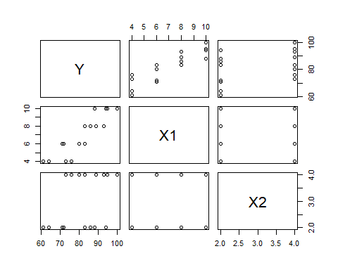
cor(data_set)
## Y X1 X2
## Y 1.0000000 0.8923929 0.3945807
## X1 0.8923929 1.0000000 0.0000000
## X2 0.3945807 0.0000000 1.0000000
# The plot shows the relationship between the dependent variable (Y) and the sum of two independent variables (X1 + X2). The points in the plot suggest a positive correlation between brand liking(Y) and with moisture content(X1) and sweetness (X2), meaning that as X1 + X2 increases, Y tends to increase as well.
- Fit the regression model to the data. State the estimated regression function. Interpret b1.
#SOLUTION
# Fit the regression model
model <- lm(Y ~ X1 + X2, data = data_set)
# Display the summary of the model
summary(model)
##
## Call:
## lm(formula = Y ~ X1 + X2, data = data_set)
##
## Residuals:
## Min 1Q Median 3Q Max
## -4.400 -1.762 0.025 1.587 4.200
##
## Coefficients:
## Estimate Std. Error t value Pr(>|t|)
## (Intercept) 37.6500 2.9961 12.566 1.20e-08 ***
## X1 4.4250 0.3011 14.695 1.78e-09 ***
## X2 4.3750 0.6733 6.498 2.01e-05 ***
## ---
## Signif. codes: 0 '***' 0.001 '**' 0.01 '*' 0.05 '.' 0.1 ' ' 1
##
## Residual standard error: 2.693 on 13 degrees of freedom
## Multiple R-squared: 0.9521, Adjusted R-squared: 0.9447
## F-statistic: 129.1 on 2 and 13 DF, p-value: 2.658e-09
# Extract coefficients
intercept <- coef(model)[1]
b1 <- coef(model)[2]
b2 <- coef(model)[3]
# Estimated regression function
#Y=β0+β1⋅X1+β2⋅X
print(paste("Estimated regression function: Y =", intercept, "+", b1, "* X1 +", b2, "* X2"))
## [1] "Estimated regression function: Y = 37.65 + 4.425 * X1 + 4.375 * X2"
# Interpret b1
print(paste("Interpretation of b1: For a one unit increase in X1, Y is expected to increase by", b1, "units, holding X2 constant."))
## [1] "Interpretation of b1: For a one unit increase in X1, Y is expected to increase by 4.425 units, holding X2 constant."
#The coefficient b1 represents the change in the degree of brand liking Y for each one-unit increase in moisture content X1, holding sweetness X2 constant
#For example, if b1 =3, it means that for every additional unit of moisture (assuming X1 increases by 1), the brand liking score Y increases by 3 points, regardless of the sweetness level X2.
- Obtain the residuals and prepare boxplot. What information does it provide?
#SOLUTION
residuals <- model$residuals
anova(model)
## Analysis of Variance Table
##
## Response: Y
## Df Sum Sq Mean Sq F value Pr(>F)
## X1 1 1566.45 1566.45 215.947 1.778e-09 ***
## X2 1 306.25 306.25 42.219 2.011e-05 ***
## Residuals 13 94.30 7.25
## ---
## Signif. codes: 0 '***' 0.001 '**' 0.01 '*' 0.05 '.' 0.1 ' ' 1
boxplot(residuals, main = "Residuals Boxplot", ylab = "Residuals")
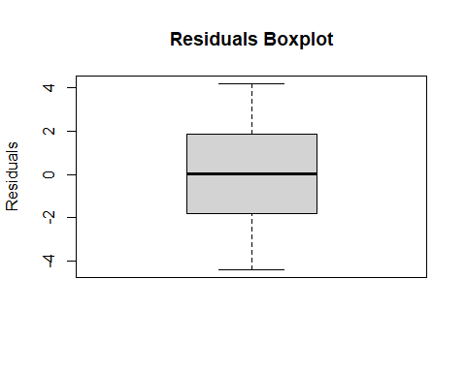
# The boxplot shows the distribution of the residuals. The residuals are centered around zero and the spread is relatively small, suggesting a good model fit. There are a few outliers.
- Plot the residuals against the fitted values, X1 and X2. Interpret them.
#SOLUTION
# Plot residuals against fitted values
fitted_value <- model$fitted.values
X1 <- data_set$X1
X2 <- data_set$X2
plot(fitted_value, residuals, main="Residuals vs Fitted Values")
abline(h=0, col="red")
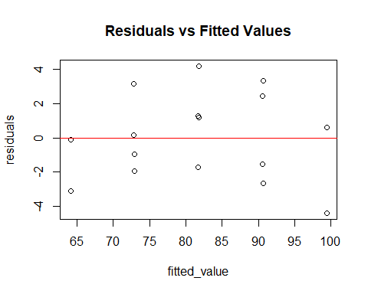
## Residuals vs Fitted Values: Residuals are randomly scattered around zero, suggesting no issues with the model's predictions across different fitted values.
# Plot residuals vs X1
plot(X1, residuals, main = "Residuals vs X1", xlab = "X1", ylab = "Residuals")
abline(h = 0, col = "blue")
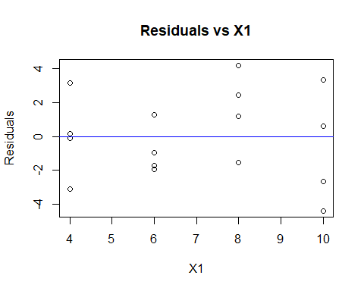
## Residuals vs X1: Shows residuals scattered around zero with no clear pattern, indicating a good fit between X1 and the model.
# Plot residuals vs X2
plot(X2, residuals, main = "Residuals vs X2", xlab = "X2", ylab = "Residuals")
abline(h = 0, col = "green")
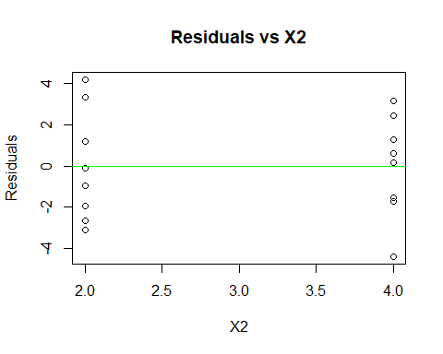
## Residuals vs X2: Shows residuals plotted against X2. The residuals are scattered randomly around zero, suggesting a good model fit.
- Prepare a normal probability plot of the residuals and obtain the test statistics. State the results.
#SOLUTION
#Normality Probability plot
plot(model)
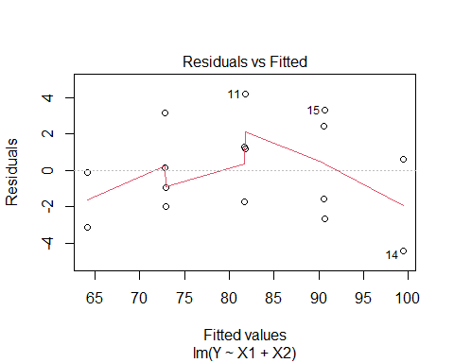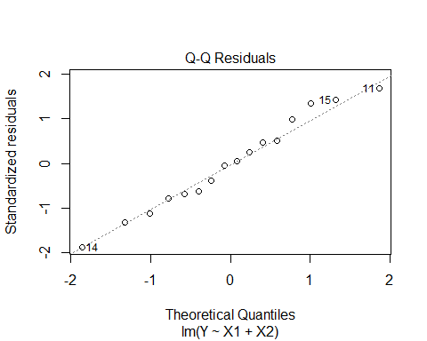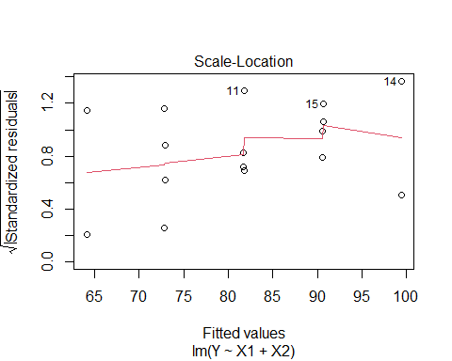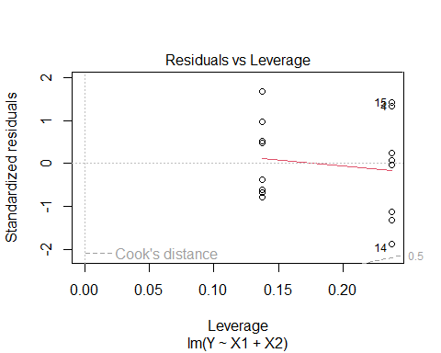
qqnorm(residuals)
qqline(residuals, col = "red")
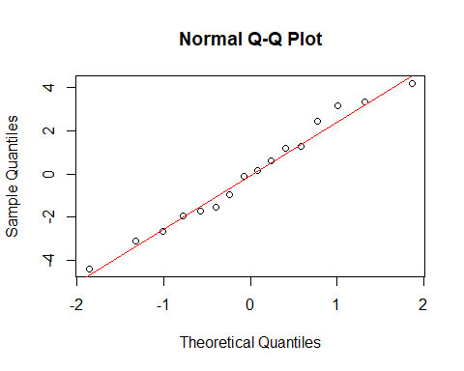
## The points fall along the diagonal line, the residuals are normally distributed.
# Shapiro-Wilk test for normality
shapiro_test <- shapiro.test(residuals)
shapiro_test
##
## Shapiro-Wilk normality test
##
## data: residuals
## W = 0.97585, p-value = 0.9222
## Since p-value is greater than defalut value(0.05), so we fail to reject the null hypothesis. This indicates tha the residuals residuals do not significantly deviate from normality.
- Test whether there is a regression relation, using α = .01. State the alternatives, decision rule, and conclusion. What does your test imply about β1 and β2?
#SOLUTION
anova_result <- anova(model)
anova_result
## Analysis of Variance Table
##
## Response: Y
## Df Sum Sq Mean Sq F value Pr(>F)
## X1 1 1566.45 1566.45 215.947 1.778e-09 ***
## X2 1 306.25 306.25 42.219 2.011e-05 ***
## Residuals 13 94.30 7.25
## ---
## Signif. codes: 0 '***' 0.001 '**' 0.01 '*' 0.05 '.' 0.1 ' ' 1
## Null Hypothesis (H0): There is no linear relationship between X1, X2, and Y (i.e., b1 = 0 and b2 = 0).
##Alternative Hypothesis (H1): At least one of X1 or X2 has a significant linear relationship with Y (i.e., at least one of b1 or b2 is not equal to 0).
##Decision Rule: Reject the null hypothesis if the p-value for either X1 or X2 is less than the significance level of 0.01.
##Conclusion: The p-values for both variables are significantly below 0.01, leading to the rejection of the null hypothesis. This indicates strong statistical evidence of a linear relationship with Y.
##Implications of b1 and b2: Both coefficients, b1 and b2, are significantly different from zero, indicating that X1 and X2 play a crucial role in predicting Y. Thus, both independent variables are important and should be included in the model.
- Calculate the coefficient of multiple determination R2. How is it interpreted here?
# SOLUTION
R_squared <- summary(model)$r.squared
print(paste("R² =", R_squared))
## [1] "R² = 0.952058973055414"
## The high R-squared value indicates that 95.21% of the variability in Y can be accounted for by the independent variables X1 and X2.
## It indicates that the model explains substantial amount of the variance in brand liking, highlighting the effectiveness of moisture content and sweetness as predictors in regression model.
- Obtain an interval estimate of E {Yx0} when X10 = 5 and X20 = 4. Use a 99 percent confidence coefficient. Interpret your interval estimate.
#SOLUTION
# New data for prediction
new_data <- data.frame(X1 = 5, X2 = 4)
# 99% confidence interval
predict(model, newdata = new_data, interval = "confidence", level = 0.99)
## fit lwr upr
## 1 77.275 73.88111 80.66889
## The confidence inverval shows that for a product with moisture content of 5 and sweetness of 4, we can be 99% confident that the average degree of brand liking will be between apporx. 73.88 and 80.67. It helps to understand customer prefernce based on product characteristics.
- Obtain a prediction interval for a new observation Y0(new) when X10 = 5 and X20. Use a 99 percent confidence coefficient.
#SOLUTION
# Prediction interval
prediction_interval <- predict(model, newdata = new_data, interval = "prediction", level = 0.99)
print(prediction_interval)
## fit lwr upr
## 1 77.275 68.48077 86.06923
# We can be 99% confident that a new data of brand liking for a product with moisture content of 5 and sweetness of 4 will fall between 68.481 and 86.069.
- The lengths of pregnancies in a small rural village are normally distributed with a mean of 265 days and a standard deviation of 15 days.
- In what range would you expect to find the middle 50% of most pregnancies?
- What proportion of pregnancies will be more than 275 days?
# SOLUTION:
mean_pregnancy <- 265
sd_pregnancy <- 15
# a. Middle 50% (Q1 and Q3)
q1 <- qnorm(0.25, mean = mean_pregnancy, sd = sd_pregnancy)
q2 <- qnorm(0.75, mean=mean_pregnancy, sd=sd_pregnancy)
print(paste("Middle 50% range of pregnancies: ",q1 , q2))
## [1] "Middle 50% range of pregnancies: 254.882653747059 275.117346252941"
# b. Proportion of pregnancies > 275 days
prob_more_275 <- 1-pnorm(275,mean = mean_pregnancy,sd=sd_pregnancy)
print(paste("Proportion of pregnancies more than 275 days: ", prob_more_275))
## [1] "Proportion of pregnancies more than 275 days: 0.252492537546923"
- A certain car model has a mean gas mileage of 34 miles per gallon (mpg) with a standard deviation 5mpg. If a car is selected at random,
- What is the probability that the mileage of the selected car is greater than 33 mpg?
- What is the probability that the mileage of the car is between 33mpg and 35mpg?
#SOLUTION
mean_gas_mileage <- 34
mileage_sd <-5
#a selected car mileage is greater than 33 mpg
prob_mileage_greater_than_33 <- 1-pnorm(33,mean=mean_gas_mileage,sd=mileage_sd)
print(paste("Probability that the mileage os selected car is greater than 33 mpg: ", prob_mileage_greater_than_33))
## [1] "Probability that the mileage os selected car is greater than 33 mpg: 0.579259709439103"
#b mileage of the car is between 33mpg and 35 mpg
prob_mileage_btn_33_35 <- pnorm(35, mean=mean_gas_mileage, sd=mileage_sd) - pnorm(33, mean=mean_gas_mileage, sd=mileage_sd)
print(paste("Probability of mileage between 33 and 35 is: ", prob_mileage_btn_33_35))
## [1] "Probability of mileage between 33 and 35 is: 0.158519418878206"

